NEW PATIENT INTAKE FORM
Feet for Miles, LLC
P.O. Box 12, O’Fallon, Missouri 63366
Phone: (636)579-2518
Email: feetformiles@gmail.com

- Dr. Veda Lewis-Simmons
- Dr. Erica Torgrude

- Dr. Erica Torgrude
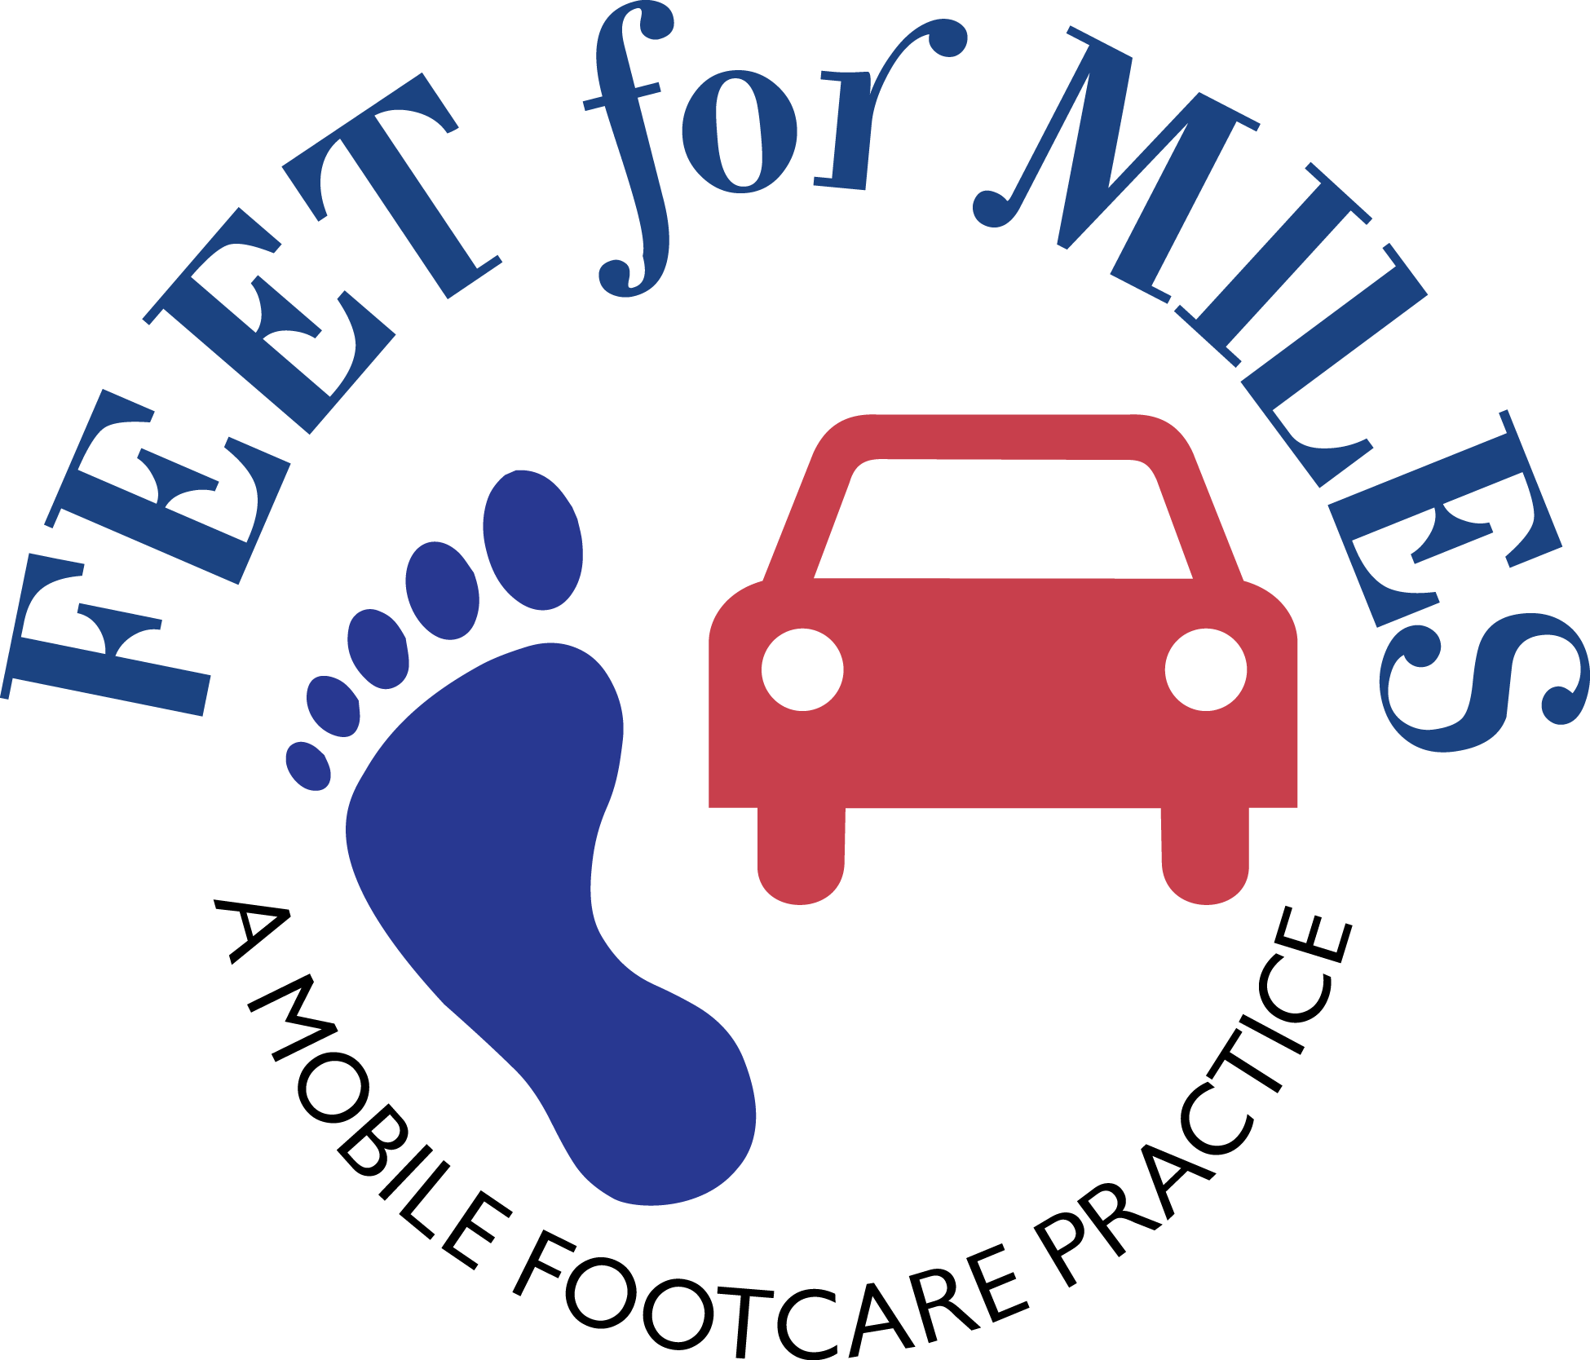
REASON FOR VISIT: PRIMARY CARE PHYSICIAN: DATE LAST SEEN:

PATIENT NAME (LAST): (FIRST): (MI):
ADDRESS: APT / BLDG #:
❑ HOME  APARTMENT  DOMICILIARY NAME OF FACILITY / APT:
CITY: STATE: ZIP: -
PATIENT PHONE: ________________________________________ IS THIS THE NUMBER TO CALL WHEN MAKING APPTS?:  YES  NO

SSN: DATE OF BIRTH: GENDER:  MALE  FEMALE
MARITAL STATUS:  SINGLE  MARRIED  WIDOWED  DIVORCED EMAIL ADDRESS:
IN THE EVENT OF AN EMERGENCY CONTACT:
RELATION TO PATIENT: PHONE:

DOES THE PATIENT HAVE A POA / GUARDIAN:  YES  NO (SKIP THIS SECTION) LEGAL STATUS:  POA  GUARDIAN
NAME: RELATIONSHIP:

ADDRESS: APT / BLDG #:
CITY: STATE: ZIP: -
POA / GUARDIAN PHONE: NOTIFY BEFORE EACH VISIT:  YES  NO

PATIENT MEDICAL CONDITIONS / DIAGNOSES:
SPECIAL VISIT INSTRUCTIONS:
IS THE PATIENT LATEX SENSITIVE:  YES  NO IS THE PATIENT CURRENTLY BEING TREATED BY A PRIMARY PHYS:  YES  NO
IS THE PATIENT CURRENTLY ON OR RECEIVING:  HOSPICE  HOME CARE  AIDE SERVICES  OTHER:
NAME OF AGENCY PROVIDING SERVICES: PHONE:

HOW DID THE PATIENT HEAR ABOUT OUR PODIATRY SERVICES:  WORD OF MOUTH  HHA  AFC/ALF  MARKETING  OTHER_______

REFERRING PARTY: PHONE:

MEDICARE NUMBER: EFFECTIVE DATE: HMO INVOLVEMENT:  YES  NO
PART B ELIGIBLE:  YES  NO
MEDICAID (IF APPLICABLE): EFFECTIVE DATE: HMO INVOLVEMENT:  YES  NO

OTHER INSURANCE CARRIER (IF APPLICABLE):
POLICY NUMBER: GROUP NUMBER:
TYPE OF POLICY:  HMO  PPO  TRADITIONAL  PFFS PHONE:

IN-OFFICE USE ONLY
WAS THE PATIENT CORRECTLY NOTIFIED OF POSSIBLE CO-PAYS / INSURANCE COVERAGE:  YES  NO
DATE OF INTAKE: ASSIGNED Podiatrist: DATE OF FIRST VISIT:
VERIFICATION:  C-SNAP  PHONE

